Lab 7: LINQ Queries using Entity Framework Core
Objective
To retrieve filtered data using LINQ with Entity Framework Core.
Commands Used
dotnet run
Code
Program.cs
using RetailInventory.Data;
using System.Linq;

using var context = new AppDbContext();

// Products with Price greater than 5000
var products = context.Products
.Where(p => p.Price > 5000)
.ToList();

Console.WriteLine("Products with Price > 5000");
Console.WriteLine("---------------------------");

foreach (var product in products)
{
Console.WriteLine($"Id : {product.Id}");
Console.WriteLine($"Name : {product.Name}");
Console.WriteLine($"Price : {product.Price}");
Console.WriteLine();
}
Category.cs
using System.Collections.Generic;

namespace RetailInventory.Models
{
public class Category
{
public int Id { get; set; }

public string Name { get; set; }

public List<Product> Products { get; set; } = new List<Product>();
}
}
Product.cs
namespace RetailInventory.Models
{
public class Product
{
public int Id { get; set; }

public string Name { get; set; }

public decimal Price { get; set; }

public int CategoryId { get; set; }

public Category Category { get; set; }
}
}
Output
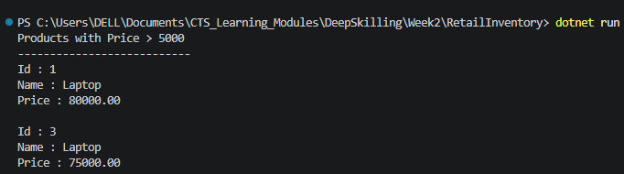
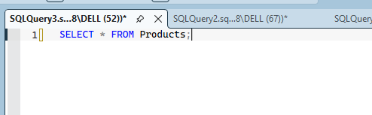
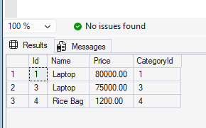
Result
The product records were filtered successfully using LINQ queries in Entity Framework Core.

